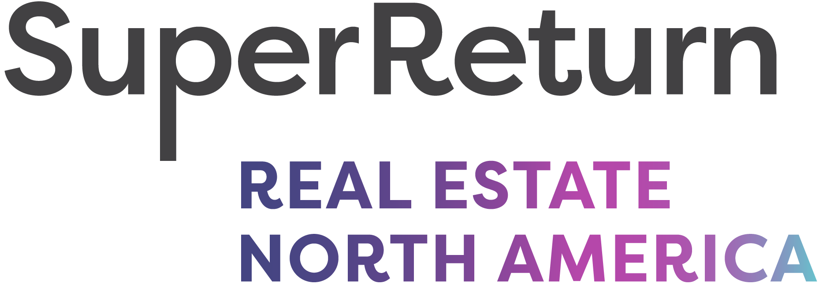

Where the future of private real estate investing takes shape

October 7-8, 2025 | Loews Coral Gables Hotel, Florida
Visit website
The new real estate event dedicated to private investing. Don’t miss…
- Meet more than 200+ senior decision-makers
- Connect with 70+ powerful LPs, and 100+ GPs
- Hear from an line-up of 40+ industry heavyweight speakers
- View the attendee list & arrange invaluable meetings ahead of time
Connecting LPs and GPs to discuss tariffs, rates and inflation, private credit, secondaries, the impact of AI and more.

LPs already confirmed include Corvest, Gavi Alliance, MSQ Invest, Nuveen Real Estate, San Antonio Fire & Police Pension Fund & Stepstone and many more.

10% discount – VIP code: FKR3664RELPI. Book now to save!

